TRIBHUVAN UNIVERSITY
PATAN MULTIPLE CAMPUS
PATANDHOKA, LALITPUR

LAB REPORT
INFORMATION SECURITY (BIT 303)

SUBMITTED BY: | SUBMITTED TO:
NAME: SURESH DAHAL | DADHI GHIMIRE
CLASS: BIT – III/I
ROLL: 23 | ________________________
DATE: 2082-…….-…….. | CHECKED BY
- Implement Caesar cipher to encrypt and decrypt message using a key k.
THEORY:
Caesar Cipher is a simple encryption technique where each letter in the plaintext is shifted by a fixed number of positions in the alphabet using key k.
Formula:
Encryption:
$$C=\left(P+k\right) mod 26$$
Decryption:
$$P=\left(C-k\right) mod 26$$
Where:
- $P$= Plaintext letter position
- $C$= Ciphertext letter position
- $k$= Key
PROGRAM:
#include <stdio.h>
#include <string.h>
#include <ctype.h>

void encrypt(char text[], int key)
{
for (int i = 0; text[i] != '\0'; i++)
{
char ch = text[i];

if (isalpha(ch))
{
char base = islower(ch) ? 'a' : 'A';
text[i] = (ch - base + key) % 26 + base;
}
}
}

void decrypt(char text[], int key)
{
for (int i = 0; text[i] != '\0'; i++)
{
char ch = text[i];

if (isalpha(ch))
{
char base = islower(ch) ? 'a' : 'A';
text[i] = (ch - base - key + 26) % 26 + base;
}
}
}

int main()
{
char text[100];
int key, choice;

printf("Enter message: ");
gets(text);

printf("Enter key: ");
scanf("%d", &key);

printf("1. Encrypt\n2. Decrypt\nEnter choice: ");
scanf("%d", &choice);

if (choice == 1)
{
encrypt(text, key);
printf("Encrypted message: %s", text);
}
else if (choice == 2)
{
decrypt(text, key);
printf("Decrypted message: %s", text);
}
else
{
printf("Invalid choice");
}

return 0;
}

OUTPUT:
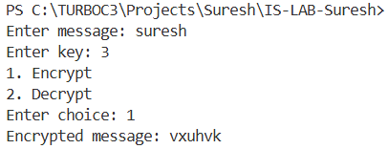
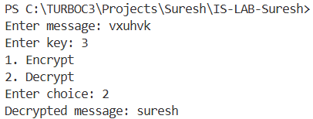

- IMPLEMENT HILL CIPHER TO ENCRYPT AND DECRYPT THE WORD “GOOD” USING KEY MATRIX$\left[\begin{matrix}7 & 3 \\ 7 & 4\end{matrix}\right]$.
THEORY:
Hill cipher is a type of block cipher that uses matrix multiplication to encrypt a group of letters simultaneously. In this cipher:
- Each letter is treated as a number
- The plaintext is divided into vectors of size n
- Encryption is done by multiplying the plaintext vector by a square matrix of key and taking the result modulo 26.
- Decryption requires finding the inverse of the key matrix.
Formula:
- Encryption: C = (K x P) (mod 26)
- Decryption: P = (K⁻¹ x P) (mod 26)
Where K is the key matrix, P is the plaintext vector, and C is the ciphertext vector.
PROGRAM:
#include <stdio.h>

int main()
{
int key[2][2] = {{7, 3}, {7, 4}};
char word[] = "GOOD";
int p[2], c[2];
int i, j;
int det = (key[0][0] * key[1][1]) - (key[0][1] * key[1][0]);
det = det % 26;

int det_inv = 0;
for (i = 0; i < 26; i++)
{
if ((det * i) % 26 == 1)
{
det_inv = i;
break;
}
}

int invKey[2][2];
invKey[0][0] = (key[1][1] * det_inv) % 26;
invKey[0][1] = ((-key[0][1] + 26) * det_inv) % 26;
invKey[1][0] = ((-key[1][0] + 26) * det_inv) % 26;
invKey[1][1] = (key[0][0] * det_inv) % 26;

printf("--- HILL CIPHER CALCULATION ---\n");
printf("Step 1: Key Matrix is [[%d, %d], [%d, %d]]\n", key[0][0], key[0][1], key[1][0], key[1][1]);
printf("Step 2: Determinant = %d, Modular Inverse = %d\n\n", det, det_inv);

printf("--- ENCRYPTION ---\n");
for (i = 0; i < 4; i += 2)
{
p[0] = word[i] - 'A';
p[1] = word[i + 1] - 'A';

for (j = 0; j < 2; j++)
{
int sum = (key[j][0] * p[0] + key[j][1] * p[1]);
c[j] = sum % 26;
printf("Calculation for %c: (%d*%d + %d*%d) mod 26 = %d (%c)\n",
word[i + j], key[j][0], p[0], key[j][1], p[1], c[j], c[j] + 'A');
}
word[i] = c[0] + 'A';
word[i + 1] = c[1] + 'A';
printf("Resulting Block: %c%c\n\n", word[i], word[i + 1]);
}

printf("--- DECRYPTION ---\n");
for (i = 0; i < 4; i += 2)
{
c[0] = word[i] - 'A';
c[1] = word[i + 1] - 'A';

for (j = 0; j < 2; j++)
{
int sum = (invKey[j][0] * c[0] + invKey[j][1] * c[1]);
int res = sum % 26;
printf("Calculation for %c: (%d*%d + %d*%d) mod 26 = %d (%c)\n",
word[i + j], invKey[j][0], c[0], invKey[j][1], c[1], res, res + 'A');
}
printf("\n");
}

return 0;
}

OUTPUT:
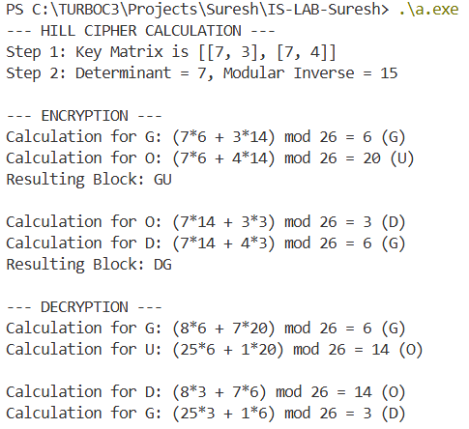

- Write a program to encrypt and decrypt the message “nocheating” with key “exam” using vigenère cipher.

THEORY:
The Vigenère Cipher is a type of cipher where each letter of the plaintext is shifted by a value determined by a corresponding letter in the keyword. Unlike a standard Caesar cipher that uses a single shift for the entire message, Vigenère uses a different shift for each character. If the keyword is shorter than the message, it is repeated cyclically.
Formula
- Encryption: C_{i} = (P_{i} + K_{i}) (mod 26)
- Decryption: P_{i}= (C_{i} – K_{i} + 26) (mod 26)
PROGRAM:
#include <stdio.h>
#include <string.h>

int main()
{
char message[] = "NOCHEATING";
char key[] = "EXAM";
int msgLen = strlen(message);
int keyLen = strlen(key);
char cipher[20], decrypted[20];
int i;

for (i = 0; i < msgLen; i++)
{
int p = message[i] - 'A';
int k = key[i % keyLen] - 'A';

cipher[i] = ((p + k) % 26) + 'A';
}
cipher[msgLen] = '\0';

for (i = 0; i < msgLen; i++)
{
int c = cipher[i] - 'A';
int k = key[i % keyLen] - 'A';

decrypted[i] = ((c - k + 26) % 26) + 'A';
}
decrypted[msgLen] = '\0';

printf("Plaintext: %s\n", message);
printf("Keyword: %s\n", key);
printf("Ciphertext: %s\n", cipher);
printf("Decrypted: %s\n", decrypted);

return 0;
}

OUTPUT:
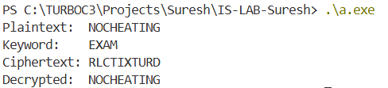

- Implement rail-fence cipher to encrypt and decrypt a message “your own message” with fence size k.
THEORY:
The Rail-Fence cipher does not change the letters themselves but rearranges their order. The message is written diagonally in a zigzag pattern on imaginary rails and then read off row by row.
- Fence Size (k): This determines the number of horizontal rows or rails used to write the message.
- Mechanism: The characters are placed in a V-shape pattern. Once the grid is filled, the ciphertext is formed by reading the characters from the first rail, then the second, and so on.
Formula/Logic
To find the position of a character in a rail at index i with key k:
- Determine the direction (downward or upward).
- The direction changes when we hit the top rail (0) or the bottom rail (k-1).

PROGRAM:
#include <stdio.h>
#include <string.h>

int main()
{
char msg[] = "SURESH";
int k = 3;
int msgLen = strlen(msg);
char rail[k][msgLen];
int i, j, row, check;

for (i = 0; i < k; i++)
for (j = 0; j < msgLen; j++)
rail[i][j] = '\n';

row = 0;
check = 0;
for (i = 0; i < msgLen; i++)
{
rail[row][i] = msg[i];

if (row == 0)
check = 0;
else if (row == k - 1)
check = 1;

if (check == 0)
row++;
else
row--;
}

printf("Ciphertext: ");
for (i = 0; i < k; i++)
{
for (j = 0; j < msgLen; j++)
{
if (rail[i][j] != '\n')
printf("%c", rail[i][j]);
}
}

printf("\nDecrypted: ");
row = 0;
check = 0;
for (i = 0; i < msgLen; i++)
{
printf("%c", rail[row][i]);

if (row == 0)
check = 0;
else if (row == k - 1)
check = 1;

if (check == 0)
row++;
else
row--;
}
printf("\n");

return 0;
}

OUTPUT:
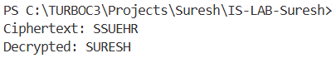
- Implement playfair cipher to encrypt and decrypt a message “this is kathmandu” using key “nepal”.
THEORY:
The Playfair Cipher is a digraph substitution cipher. Instead of shifting single letters, it encrypts letters in group of two. This makes it more secure than simple substitution ciphers.
- The 5x5 Matrix We create a grid using the key "NEPAL" first, then fill the rest with the remaining alphabet. Since there are 26 letters and only 25 slots, I and J share a single cell.
- The Rules of Encryption
- Same Row: Replace each letter with the one to its immediate right.
- Same Column: Replace each letter with the one immediately below it.
- Rectangle Rule: if letters are in different rows/columns, they form a rectangle. Swap them with the letters in the opposite corners of that rectangle.
PROGRAM:
#include <stdio.h>
#include <string.h>

int main() {
char matrix[5][5] = {
{'N', 'E', 'P', 'A', 'L'},
{'B', 'C', 'D', 'F', 'G'},
{'H', 'I', 'K', 'M', 'O'},
{'Q', 'R', 'S', 'T', 'U'},
{'V', 'W', 'X', 'Y', 'Z'}};
char msg[] = "THISISKATHMANDU";
int len = strlen(msg);
int r1, c1, r2, c2;

printf("Key: NEPAL | Message: %s\n", msg);
printf("Ciphertext: ");

for (int i = 0; i < len; i += 2)
{
char a = msg[i];
char b = (i + 1 < len) ? msg[i + 1] : 'X';

for (int r = 0; r < 5; r++)
{
for (int c = 0; c < 5; c++)
{
if (matrix[r][c] == a)
{
r1 = r;
c1 = c;
}
if (matrix[r][c] == b)
{
r2 = r;
c2 = c;
}
}
}

if (r1 == r2)
printf("%c%c", matrix[r1][(c1 + 1) % 5], matrix[r2][(c2 + 1) % 5]);
else if (c1 == c2)
printf("%c%c", matrix[(r1 + 1) % 5][c1], matrix[(r2 + 1) % 5][c2]);
else
printf("%c%c", matrix[r1][c2], matrix[r2][c1]);
}
printf("\n");
return 0;
}

OUTPUT:
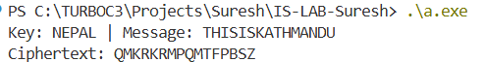

- Implement one-time pad algorithm to encrypt and decrypt a message.
THEORY:
The One-Time Pad is a symmetric key encryption technique that is considered theoretically unbreakable when used correctly. It encrypts plain text by combining it with a random secret key of the same length.
PROGRAM:
#include <stdio.h>
#include <string.h>

int main() {
char plaintext[] = "SURESH";
char key[] = "XMCKLZ";
int len = strlen(plaintext);
char ciphertext[len + 1], decrypted[len + 1];
int i;

printf("Plaintext: %s\n", plaintext);
printf("Key: %s\n\n", key);

for (i = 0; i < len; i++)
{
int p = plaintext[i] - 'A';
int k = key[i] - 'A';

ciphertext[i] = ((p + k) % 26) + 'A';
}
ciphertext[len] = '\0';
printf("Ciphertext: %s\n", ciphertext);

for (i = 0; i < len; i++)
{
int c = ciphertext[i] - 'A';
int k = key[i] - 'A';

decrypted[i] = ((c - k + 26) % 26) + 'A';
}

decrypted[len] = '\0';
printf("Decrypted: %s\n", decrypted);

return 0;
}

OUTPUT:
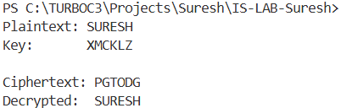

- Implement extended Euclidean algorithm to find multiplicative inverse of an integer mod n.
THEORY:
The Extended Euclidean Algorithm is an extension of the standard Euclidean Algorithm. While the standard version only finds the Greatest Common Divisor (GCD) of two integers a and b, the extended version also finds the coefficients x and y such that:
ax + by = GCD (a, b)
In cryptography, this is primarily used to find the multiplicative inverse. An integer x is the multiplicative inverse of a mod n if:
ax ≡1 mod n
PROGRAM:
#include <stdio.h>

int extendedGCD(int a, int n) {
int m0 = n, t, q;
int x0 = 0, x1 = 1;
if (n == 1) return 0;

while (a > 1) {
q = a / n;
t = n;

n = a % n;
a = t;
t = x0;

x0 = x1 - q * x0;
x1 = t;
}

if (x1 < 0) x1 += m0;
return x1;
}
int main() {
int a = 11, n = 26;

printf("Finding Multiplicative Inverse of %d mod %d...\n", a, n);

int inverse = extendedGCD(a, n);

printf("The Multiplicative Inverse is: %d\n", inverse);
printf("Check: (%d * %d) %% %d = %d\n", a, inverse, n, (a * inverse) % n);

return 0;
}

OUTPUT:
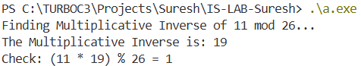

- Write a program to find all the primitive root of prime number p.
THEORY:
A primitive root modulo $p$is a number $g$such that its powers generate all numbers from 1 to $p-1$ when taken modulo $p$.
That means:
$$g^{1},g^{2},g^{3},…,g^{p-1}mod p$$
gives all values from 1 to $p-1$without repeating.
Algorithm:
- Input prime number $p$
- Compute $n=p-1$
- Find prime factors of $n$
- For each number $g=2$to $p-1$:
  - Calculate $g^{n/q} mod p$for each factor $q$
  - If result is 1 for any, skip it
  - Otherwise, it is a primitive root
- Print all such values

PROGRAM:
#include <stdio.h>
#include <math.h>

long long power(long long base, long long exp, long long mod) {
long long res = 1;
base = base % mod;
while (exp > 0) {
if (exp % 2 == 1)
res = (res * base) % mod;
base = (base * base) % mod;
exp = exp / 2;
}
return res;
}

int isPrimitiveRoot(int g, int P) {
int values[P];
for (int i = 0; i < P; i++)
values[i] = 0;

long long current = 1;
for (int i = 1; i < P; i++) {
current = (current * g) % P;
if (values[current] == 1)
return 0;
values[current] = 1;
}
return 1;
}

int main() {
int P = 7;
printf("Primitive roots of %d are: ", P);

for (int g = 2; g < P; g++)
{
if (isPrimitiveRoot(g, P))
{
printf("%d ", g);
}
}
printf("\n");

return 0;
}

OUTPUT:
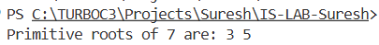

- Write a program to find totient number of given integer n.
THEORY:
Euler's Totient Function, denoted as ɸ(n), is a fundamental function in number theory and cryptography. It counts the number of positive integers up to n that are relatively prime to n.
Working Principle
- Relatively Prime: Two numbers a and n are relatively prime if their Greatest Common Divisor is 1.
- Definition: For a given integer n, ɸ(n) is the count of numbers i such that 1 ≤ i < n and gcd(i, n) = 1.
- Prime Numbers: If n is a prime number P, then all numbers from 1 to P-1 are relatively prime to it, so ɸ(P) = P - 1.
PROGRAM:
#include <stdio.h>

int gcd(int a, int b)
{
if (a == 0)
return b;
return gcd(b % a, a);
}

int phi(int n)
{
int result = 1;
for (int i = 2; i < n; i++)
{
if (gcd(i, n) == 1)
{
result++;
}
}
return result;
}

int main()
{
int n;
printf("Enter the value of n: ");
scanf("%d", &n);

printf("Euler's Totient Number phi(%d) = %d\n", n, phi(n));

return 0;
}

OUTPUT:
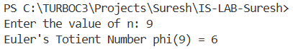
- Write a program to implement Fermat’s theorem a^{p-1}=1(mod p). (Where a and p are relatively prime)
THEORY:
Fermat's Little Theorem is a fundamental theorem in number theory, which provides a property of prime numbers. It states that if p is a prime number and a is any integer such that a is not divisible by p (meaning a and p are relatively prime), then:
a^{p-1} ≡ 1 mod(p)
PROGRAM:
#include <stdio.h>

long long power(long long base, long long exp, long long mod)
{
long long res = 1;
base = base % mod;
while (exp > 0)
{
if (exp % 2 == 1)
res = (res * base) % mod;
base = (base * base) % mod;
exp = exp / 2;
}
return res;
}

int gcd(int a, int b)
{
if (a == 0)
return b;
return gcd(b % a, a);
}

int main()
{
int a, p;

printf("Enter an integer (a): ");
scanf("%d", &a);
printf("Enter a prime number (p): ");
scanf("%d", &p);

if (gcd(a, p) != 1)
{
printf("Error: a and p must be relatively prime (gcd=1).\n");
}
else
{
long long result = power(a, p - 1, p);

printf("\nVerification of Fermat's Little Theorem:\n");
printf("%d^(%d-1) mod %d = %lld\n", a, p, p, result);

if (result == 1)
{
printf("Result is 1. Theorem holds true.\n");
}
else
{
printf("Theorem failed (p might not be prime).\n");
}
}

return 0;
}

OUTPUT:
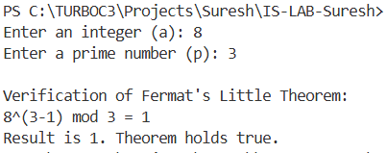
- Implement Miller Rabin algorithm to determine whether a given odd integer is composite or may be prime (inconclusive).
THEORY:
The Miller-Rabin algorithm is a probabilistic primality test used to determine if a given odd integer n is composite or probably prime. Unlike deterministic tests, it uses random bases to check for primality, making it much faster for very large numbers.
Working Principle
- Factorization: We write (n - 1) as (2^{s} * d), where d is an odd number.
- Witness Selection: We pick a random integer 'a' between 2 and n - 2.
- The Test: We compute x = (a^{d}) mod n.
  - If x = 1 or x = n - 1, the number n is probably prime for this witness.
  - If not, we square x repeatedly up to s-1 times). If any resulting x equals n - 1, the number is probably prime.
- Inconclusive vs. Composite: If none of these conditions are met, the number is definitely composite. If they are met, we repeat the test with different values of 'a' to increase confidence.
PROGRAM:
#include <stdio.h>
#include <stdlib.h>

long long power(long long base, long long exp, long long mod)
{
long long res = 1;
base %= mod;
while (exp > 0)
{
if (exp % 2 == 1)
res = (res * base) % mod;
base = (base * base) % mod;
exp /= 2;
}
return res;
}

int millerRabin(long long n, int k)
{
if (n <= 1 || n == 4)
return 0;
if (n <= 3)
return 1;

long long d = n - 1;
int s = 0;
while (d % 2 == 0)
{
d /= 2;
s++;
}

for (int i = 0; i < k; i++)
{
long long a = 2 + rand() % (n - 4);
long long x = power(a, d, n);

if (x == 1 || x == n - 1)
continue;

int composite = 1;
for (int r = 1; r < s; r++)
{
x = (x * x) % n;
if (x == n - 1)
{
composite = 0;
break;
}
}
if (composite)
return 0;
}
return 1;
}
int main()
{
long long n;
int k = 5;

printf("Enter an odd integer: ");
scanf("%lld", &n);

if (n % 2 == 0 && n != 2)
{
printf("%lld is Composite.\n", n);
}
else if (millerRabin(n, k)) {
printf("%lld is Probably Prime (Inconclusive).\n", n);
}
else {
printf("%lld is Composite.\n", n);
}

return 0;
}

OUTPUT:
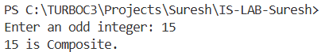
- WAP to establish a private key using Diffie Hellman key Exchange.
THEORY:
The Diffie-Hellman key exchange is a method for two parties to securely establish a shared private key over a public channel. It is not an encryption algorithm itself, but a way to agree on a secret key that can later be used for symmetric encryption like AES.
Working Principle:
Two users (say A and B) agree on:
- A prime number $p$
- A primitive root $g$
These values are public.
Steps:
Step 1: Private Keys
- A selects private key $a$
- B selects private key $b$
Step 2: Public Keys
- A computes:
$$A=g^{a}mod p$$
- B computes:
$$B=g^{b}mod p$$
They exchange these values.
Step 3: Shared Secret Key
- A computes:
$$K=B^{a}mod p$$
- B computes:
$$K=A^{b}mod p$$
Both get the same key:
$$K=g^{ab}mod p$$
PROGRAM:
#include <stdio.h>

long long power(long long base, long long exp, long long mod) {
long long res = 1;
base %= mod;
while (exp > 0) {
if (exp % 2 == 1)
res = (res * base) % mod;
base = (base * base) % mod;
exp /= 2;
}
return res;
}

int main() {
long long q, g, Xa, Xb, Ya, Yb, Ka, Kb;

q = 23;
g = 5;
printf("Publicly Shared Prime (q): %lld\n", q);
printf("Publicly Shared Root (g): %lld\n\n", g);

Xa = 6;
Xb = 15;
printf("User A Private Key (Xa): %lld\n", Xa);
printf("User B Private Key (Xb): %lld\n\n", Xb);

Ya = power(g, Xa, q);
Yb = power(g, Xb, q);
printf("User A Public Value (Ya): %lld\n", Ya);
printf("User B Public Value (Yb): %lld\n\n", Yb);

Ka = power(Yb, Xa, q);
Kb = power(Ya, Xb, q);

printf("Secret Key calculated by User A: %lld\n", Ka);
printf("Secret Key calculated by User B: %lld\n", Kb);

if (Ka == Kb) {
printf("\nSuccess: Shared Private Key established!\n");
}
return 0;
}

OUTPUT:
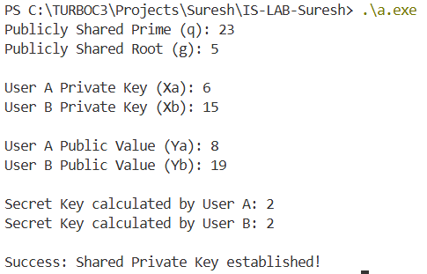
- Write a program to implement RSA algorithm to encrypt a message.
THEORY:
RSA (Rivest-Shamir-Adleman) is an asymmetric cryptographic algorithm. It uses a public key for encryption and a private key for decryption. The security of RSA is built on the mathematical difficulty of factoring the product of two large prime numbers.
Working Principle
- Key Generation:
  - Select two distinct prime numbers, p and q.
  - Compute n = p * q. This n is the modulus for both keys.
  - Compute Euler’s Totient function: ɸ(n) = (p - 1) * (q - 1).
  - Choose an integer e such that 1 < e < ɸ(n) and gcd(e, ɸ(n)) = 1. (Commonly e = 65537).
  - Compute d such that (d * e) % ɸ(n) = 1. (This uses the Extended Euclidean Algorithm).
- Encryption: The ciphertext C is calculated as: C = (Me) mod n.
- Decryption: The plaintext message M is recovered as: M = (C^{d}) mod n.

PROGRAM:
#include <stdio.h>
#include <math.h>

long long power(long long base, long long exp, long long mod) {
long long res = 1;
base %= mod;
while (exp > 0)
{
if (exp % 2 == 1)
res = (res * base) % mod;
base = (base * base) % mod;
exp /= 2;
}
return res;
}

int gcd(int a, int b) {
while (b != 0) {
int temp = b;
b = a % b;
a = temp;
}
return a;
}

int main() {
long long p = 3, q = 11;
long long n = p * q;
long long phi = (p - 1) * (q - 1);

long long e = 7;
while (e < phi) {
if (gcd(e, phi) == 1)
break;
else
e++;
}

long long d = 0;
for (long long i = 1; i < phi; i++) {
if ((e * i) % phi == 1) {
d = i;
break;
}
}

long long msg = 65;
printf("Original Message: %lld\n", msg);
printf("Public Key (e, n): (%lld, %lld)\n", e, n);
printf("Private Key (d, n): (%lld, %lld)\n\n", d, n);

long long c = power(msg, e, n);
printf("Encrypted Message (Ciphertext): %lld\n", c);

long long m = power(c, d, n);
printf("Decrypted Message (Plaintext): %lld\n", m);

return 0;
}

OUTPUT:
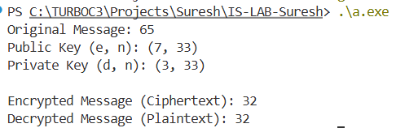
- Implement RSA based Digital signature to sign and verify a digital signature.
THEORY:
A Digital Signature is a mathematical technique used to validate the authenticity and integrity of a message, software, or digital document. While RSA encryption uses the public key to encrypt and the private key to decrypt, a Digital Signature reverses this process:
- Signing: The sender uses their Private Key to encrypt a message digest. This locks the identity of the sender to the message.
- Verification: The receiver uses the sender's Public Key to decrypt the signature. If the result matches the original message, the signature is valid.
PROGRAM:
#include <stdio.h>

long long power(long long base, long long exp, long long mod) {
long long res = 1;
base %= mod;
while (exp > 0) {
if (exp % 2 == 1)
res = (res * base) % mod;
base = (base * base) % mod;
exp /= 2;
}
return res;
}

int main() {
long long p = 3, q = 11;
long long n = p * q;
long long phi = (p - 1) * (q - 1);
long long e = 7;
long long d = 3;

long long M = 14;

printf("Original Message (M): %lld\n", M);
printf("Public Key (e, n): (%lld, %lld)\n", e, n);
printf("Private Key (d, n): (%lld, %lld)\n\n", d, n);

long long S = power(M, d, n);
printf("Digital Signature (S) created: %lld\n", S);

long long M_prime = power(S, e, n);
printf("Decrypted value from signature: %lld\n\n", M_prime);

if (M_prime == M) {
printf("Verification SUCCESS: The signature is valid and authentic.\n");
}
else {
printf("Verification FAILED: The signature or message has been tampered with.\n");
}

return 0;
}

OUTPUT:
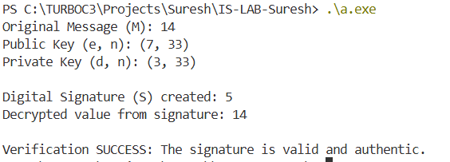
- Implement DES algorithm in python.
THEORY:
DES (Data Encryption Standard) is a symmetric-key block cipher that encrypts data in 64-bit blocks using a 56-bit key. It follows a Feistel Network structure, meaning it splits the block into two halves and applies a series of transformations over 16 rounds.
Working Principle
- Initial Permutation (IP): The 64-bit input block is rearranged according to a fixed table.
- Key Schedule: The 64-bit input key is reduced to 56 bits and then shifted and permuted to create sixteen 48-bit "round keys."
- Feistel Rounds: In each of the 16 rounds, the right half of the data is expanded, XORed with the round key, passed through S-Boxes (Substitution), and permuted.
- Final Permutation (FP): The inverse of the IP is applied to produce the ciphertext.
PROGRAM:
from Crypto.Cipher import DES
from Crypto.Util.Padding import pad, unpad

def encrypt(msg, key):
cipher = DES.new(key, DES.MODE_ECB)
padded_text = pad(msg.encode(), 8)
encrypted_text = cipher.encrypt(padded_text)
return encrypted_text

def decrypt(cipher_text, key):
cipher = DES.new(key, DES.MODE_ECB)
decrypted_text = unpad(cipher.decrypt(cipher_text), 8)
return decrypted_text.decode()

if __name__ == "__main__":
key = b'8bytekey'
message = input("Enter message: ")

encrypted = encrypt(message, key)
print("Encrypted (in bytes):", encrypted.hex())

decrypted = decrypt(encrypted, key)
print("Decrypted message:", decrypted)

OUTPUT:
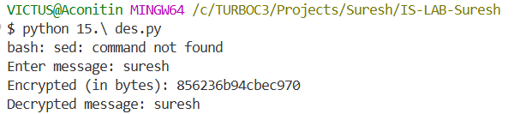

- Implement AES algorithm in python.
THEORY:
The Advanced Encryption Standard (AES) is a symmetric key encryption algorithm used worldwide for securing data. It is stronger and more secure than DES. Unlike DES, which uses a Feistel network, AES uses a Substitution-Permutation Network.
Key Features
- Block size: 128 bits
- Key sizes:
  - 128-bit
  - 192-bit
  - 256-bit
PROGRAM:
from Crypto.Cipher import AES
from Crypto.Util.Padding import pad, unpad

def encrypt(message, key):
cipher = AES.new(key, AES.MODE_ECB)
padded_msg = pad(message.encode(), 16)
encrypted = cipher.encrypt(padded_msg)
return encrypted

def decrypt(cipher_text, key):
cipher = AES.new(key, AES.MODE_ECB)
decrypted = unpad(cipher.decrypt(cipher_text), 16)
return decrypted.decode()

if __name__ == "__main__":
key = b'1234567890123456'
message = input("Enter message: ")

encrypted = encrypt(message, key)
print("Encrypted (bytes):", encrypted)

decrypted = decrypt(encrypted, key)
print("Decrypted message:", decrypted)

OUTPUT:
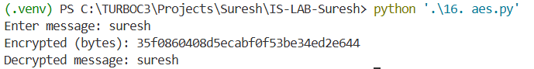
- Implement MD5 algorithm in python.
THEORY:
MD5 is a cryptographic hash function that produces a 128-bit (16-byte) hash value, usually represented as a 32-digit hexadecimal number. It was designed to be a cryptographic hash function for verifying data integrity.
How it works:
- Padding: The message is padded so its length is congruent to 448 mod 512.
- Append Length: A 64-bit representation of the original length is added.
- Initialize Variables: Four 32-bit registers (A, B, C, D) are initialized with specific constants.
- Process Blocks: The message is processed in 512-bit blocks. Each block goes through 4 rounds of complex logical operations (F, G, H, I function).
- Output: The final values in the registers are concatenated to form the hash.
PROGRAM:
import hashlib

def generate_md5(message):
result = hashlib.md5(message.encode())
return result.hexdigest()

if __name__ == "__main__":
message = input("Enter message: ")

md5_hash = generate_md5(message)
print("MD5 Hash:", md5_hash)

OUTPUT:
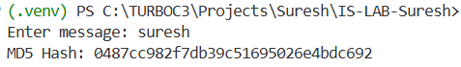
- Implement SHA 1 algorithm in python.
THEORY:
SHA-1 is a cryptographic hash function that converts any input data into a fixed-size 160-bit hash value. It is used for data integrity verification.
Working Principle
- Pad the message to make its length a multiple of 512 bits
- Split the message into 512-bit blocks
- Process each block using SHA-1 compression function
- Combine results to produce a 160-bit hash
PROGRAM:
import hashlib

def generate_sha1(message):
result = hashlib.sha1(message.encode())
return result.hexdigest()

if __name__ == "__main__":
message = input("Enter message: ")
sha1_hash = generate_sha1(message)
print("SHA-1 Hash:", sha1_hash)

OUTPUT:
